# CS 255 System Design Document

## UML Diagrams

### UML Use Case Diagram

### UML Activity Diagrams

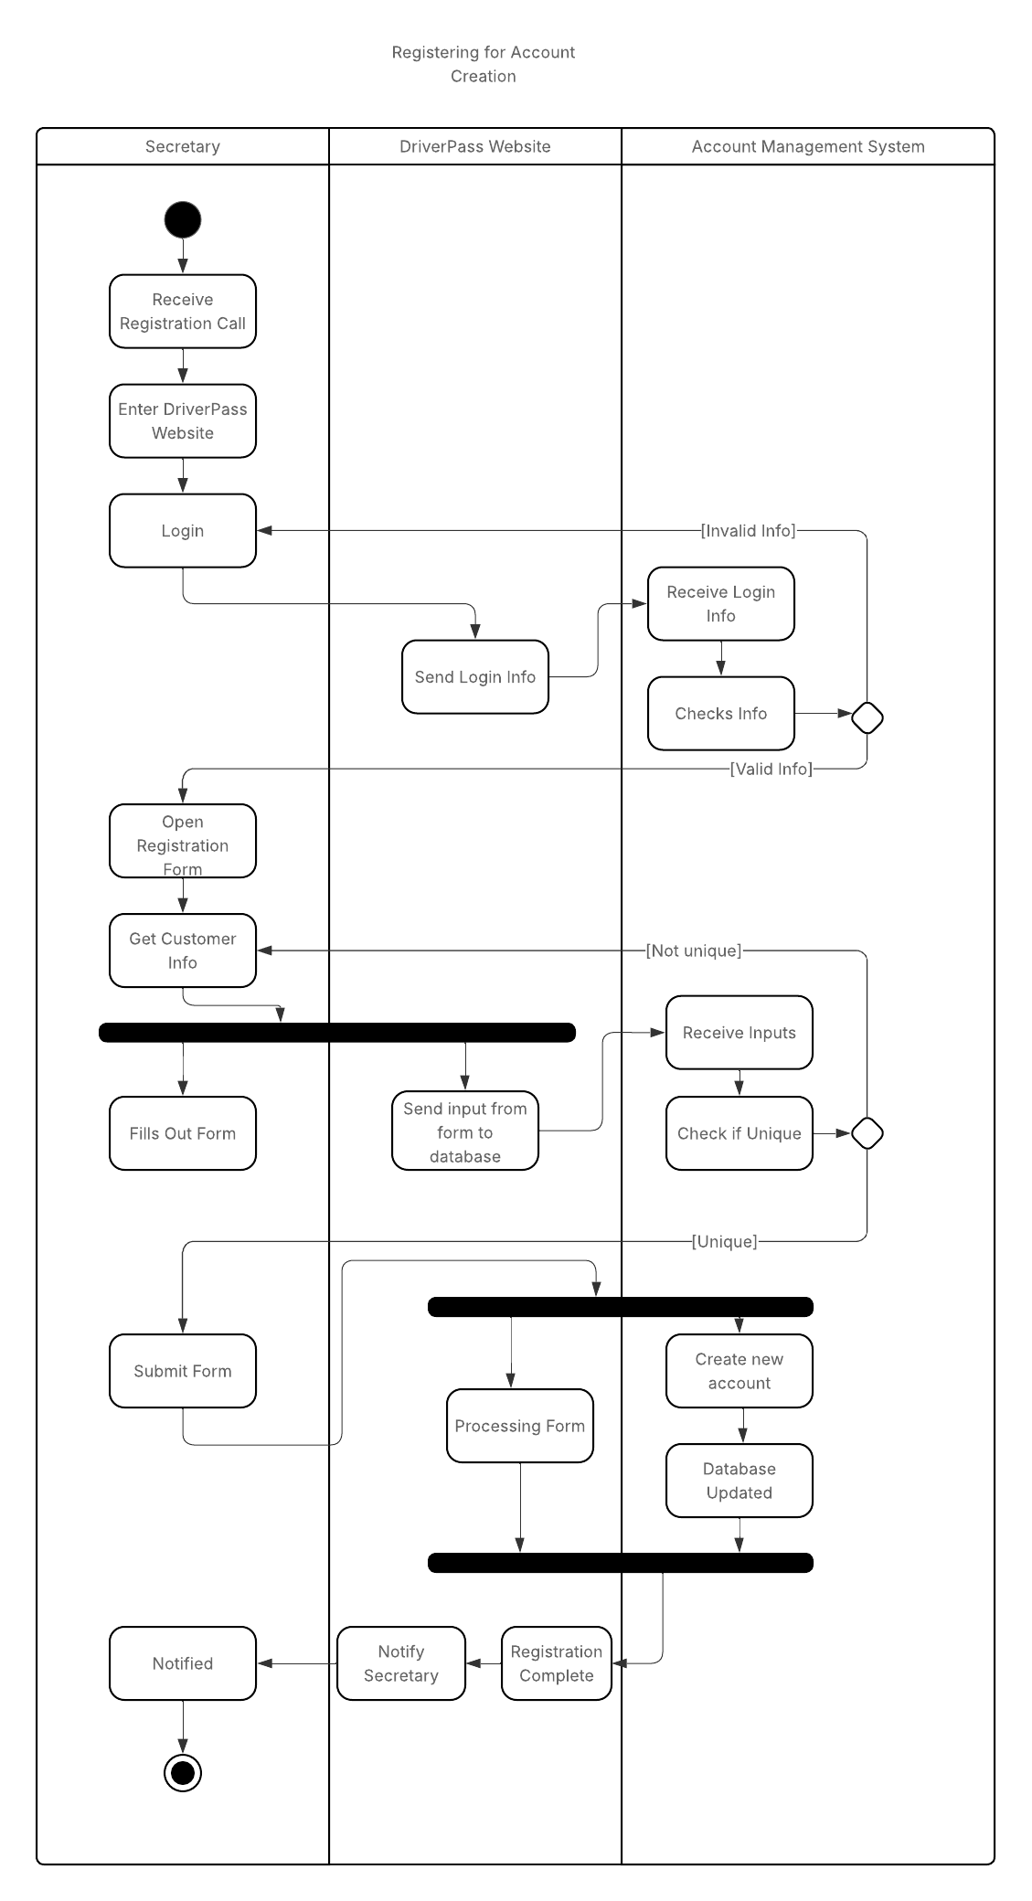

### UML Sequence Diagram

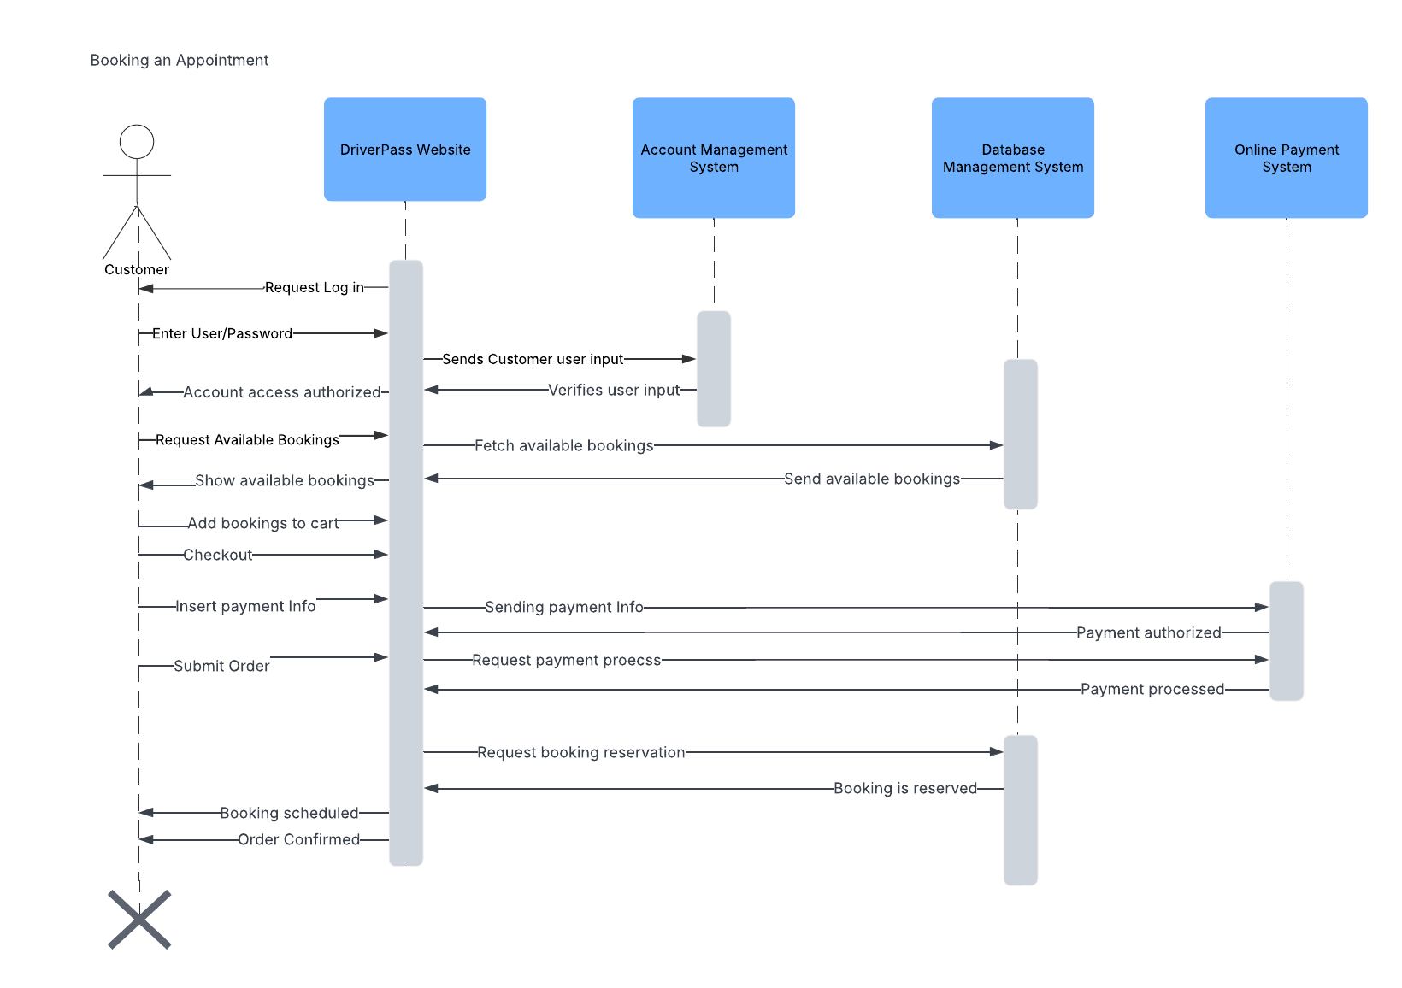

### UML Class Diagram

## Technical Requirements

Based on the functional and nonfunctional requirements, if we’re going to make a web-based application, we’re proposing for the system to run on a UNIX operating system like Linux due to it’s efficiency in memory management system, security in encryption, as well as its cost effectiveness, and the many development tools available. Our clients want to use a cloud database, so it can manage user accounts without the hassle of worrying about security as well as managing any large datastores we may need to handle. We’ll also want to connect to an online payment system for added security for sensitive data inputs from customers. E.g. PayPal, credit cards, stripe.